**Haydn’s Development of the Symphony**

Joseph Haydn (31 March 1732 – 31 May 1809) was the most celebrated composer of the Classical period. Due to his contributions to music, he earned the name “Father of Symphony”. In fact, G.B. Sammartini should have this name, because he was the first person who established the orchestral music and his symphony has influenced Haydn but Haydn denied it.[1] After that, symphonies were developed by Manheim orchestra which is under the lead of Johann Stamitz.[2] Anyhow, Haydn is called the “Father of Symphony” because of his influence of symphony on the later composers. Haydn started his career during the patronage system in the late Baroque period and ended as a freelancer in the early 19th century.[3] His symphonies are sorted by numbers, but the numbering is not reflected in the order which they were written nor by their total number which is approximately 106.[4] In addition, most of his symphonies have four movements: 1st is usually start with a slow prelude and after that fast sonata-form movement comes in; 2nd is a slow movement; 3rd is a minuet and trio; and lastly, a fast finale in sonata or rondo form.[5] Normally, all movements are in the same key (except the second movement), which are usually in the subdominant or dominant key.[6] This essay will discuss musical features in Haydn’s symphony from different periods (early, middle, late), and the comparison between these periods.

Haydn’s early symphonies were typically scored for two oboes, two horns and strings, besides Symphony no.32 (with trumpets).[7] Furthermore, most of the early symphonies are in three movements: fast-slow-fast, but he soon expanded his symphony into four-movements with an added minuet as the third movement.[8] [9] Haydn’s early symphonies have the elements which are from the Baroque period. His early symphonies also introduced the use of reduced textures, bold solo lines, upper-register writing, characterized bass lines, brilliant use of color and timing for dramatic effect.[10]Another distinguishing feature is the use of woodwinds; it has become freer, with constant solo passages conjunction.[11]

The Matin–Midi–Soir trilogy was the first symphonic composition after he entered the Esterházy.[12] Haydn’s Symphony no.8 in G major “Le Soir” demonstrates some features that represented his early period. This symphony is composed in 1761, when he was under the employment of the Esterhazy family. *Concerto Grosso* technique is used in this trilogy. The instruments in Symphony no.8 are one flute, two oboes, one bassoon, two horns in G, basso continuo with harpsichord and strings that include solo first and second violin, solo cello, and double bass.

The first movement of Symphony no.8 does not start with *Concerto Grosso*. The theme in this movement is from the first 8 bars in the violins’ section, which carried throughout the whole movement with various forms. Figure 1 shows the opening theme from first violin, which sounds like a dance-like melody. There is a feature in this movement has shown that Haydn was influenced by the Vivladian concerto, which is the sequence.[13] Figure 2 illustrates the sequence from basso continuo at bar 122 that emphasizes the up-beat.

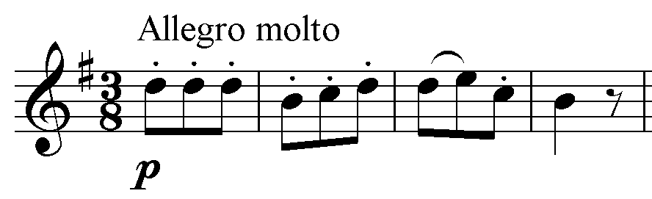

Figure 1

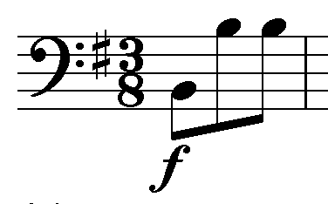  
**Figure 2**

His early symphony’s second movement is usually calm and gentle. *Concerto Grosso* technique is used in this movement. Woodwind has become much more significant, since the soloist is bassoon. Violins and solo bassoon present the song-like theme, sometimes with cello filling in the gaps of the theme.

The following Menuetto is probably the most well-known part in the trilogy. Woodwinds are featured in Minuet, because it gives more opportunities to woodwinds to carry the melody. The instruments that are used in Minuet are the same as the first movement. Whereas Trio only remained as strings with solo, double bass and *basso continuo*, traditionally double bass has a solo part in Trio.[14]

The finale of Symphony no.8 is named “La Tempesta”, which means The Storm. This movement starts with the solo violin playing the repeated octave leaping to build tension, soon the same idea shifts to the cello. Woodwinds are still representing an important role in this movement. For example, figure 3 shows the idea of describing the lightning strikes or the raindrops are being presented by the flute.[15] Also, Vivaldi’s Seasons probably inspire this finale.[16]

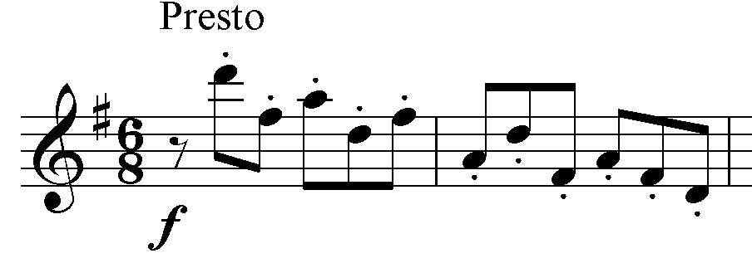

Figure 3

As we can see, Haydn’s Symphony no.8 has included the influences which are from Baroque period. Also, the use of woodwinds has become much more important in his early symphonies. However, compared to the earlier music for example Vivaldi’s and Scarlatti’s, this trilogy is considered very modern.[17] The ideas and images from Baroque period affected this symphony as well, for instance the lightning strikes in the finale.

Haydn’s middle period is also called *Sturm und Drang* period. Compared to the early symphony, his middle symphony has become more mature and developed. His middle symphonies are more contrapuntal, carrying a more complicated rhythm, posing greater technical difficulty, and with a more complex harmony.[18] Besides that, Haydn introduced more dramatic materials, such as dynamic changes from forte to piano, the crescendos, and sforzati.[19] Furthermore, his middle symphony’s harmonic palette is richer and contains a wider modulation range than the early symphony.[20] Minor mode is the most notable feature in this period because Haydn wrote six minor works in this period and these symphonies flows with the emotional and agitated expression that shows his *Sturm und Drang style.[21]*

Haydn’s minor mode becomes a feature in his middle symphonies, he has ten minors in 104 symphonies and six of them are composed in this period.[22] Symphony no.52 in C minor demonstrates some features in his middle period. This symphony composed in 1772 and it is the last composition of the *Sturm und Drang* symphonies. Also, this symphony was described by Landon as the grandfather of Beethoven’s Symphony no.5.[23] This symphony is scored for 2 oboes, bassoon, 2 horns (in alto C, E flat and basso C), and basso continuo with harpsichord and strings that include first violin, second violin, viola and cello.

The first movement starts with a strong and aggressive unison. It shows the characteristic of *Sturm und Drang* style. Figure 4 illustrates the first theme of this movement from first violin. The second theme (figure 5) presents a strong and comedic contrast to the first theme. This is a technique that Haydn usually used in his middle symphonies.[24] In the development section, two themes are used together and it creates a stormy touch. Also, the powerful tensions are developed, due to the rapid and unexpected changes between two different styles.[25]

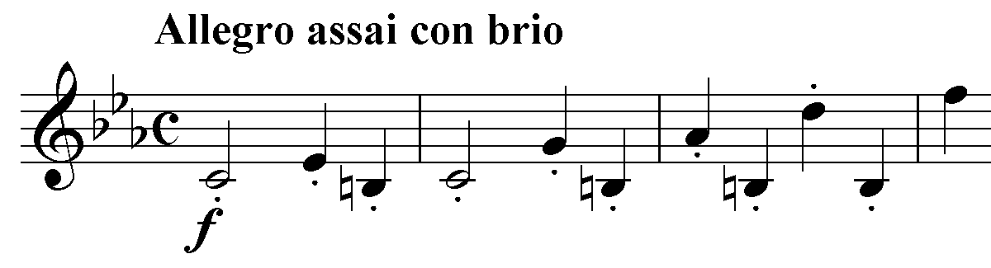

Figure 4

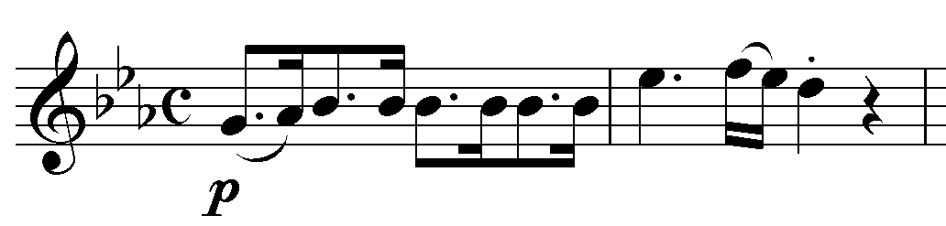

Figure 5

The instruments in second movement are changed, Horn in C alto and E flat replaced by 2 Horns in C basso. In addition, violins are muted for producing the nasal effect that Haydn liked so much.[26] The dance-like theme of this movement is occasionally interrupted by strings’ darker moments, because Haydn was trying to keep the tension tight for the symphony.[27]

The third movement remains the horns in C basso. This movement highlights the use of syncopation, especially in Trio. In the second part of minuet introduced the up-beat *forzati* which is a hint of Trio.[28] Figure 6 shows a passage from first violin in bar 43 of the following Trio that emphasizes the use of syncopation.

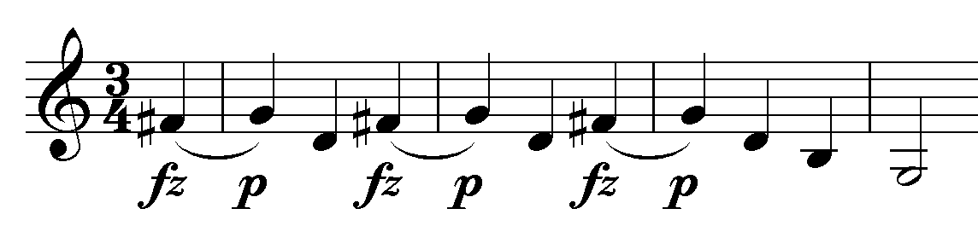

Figure 6

The finale of this symphony is cruel and forceful forward movement.[29] This movement has the same instruments as the first movement. The main theme is presented by the syncopation of the first and second violins. This movement only has one section (bar 93) that we have contrasted *forte* and *piano*, and the rest either stay in *forte* or *piano.[30]*

Compare to the early symphonies, middle symphonies are much more mature with some significant changes. Spectacularly, *Sturm und Drang* style was famous in his middle period, which is why this popular style strongly influenced him, and widely used in this symphony. In addition, syncopation is used frequently in his middle period.

In his late period, Johann Peter Salomon invited Haydn to compose and conduct symphonies in London. [31] The orchestration is larger than before, with trumpets, timpani, and clarinets in his late symphonies except Symphony no.102.[32] His late symphony has more daring harmonic conceptions, intensified rhythmic drive, and of course his memorable thematic inventions.[33] Moreover, woodwinds and string bass are used more often and have more solo passages than before.[34] Besides that, the dramatic material is also a notable feature. For instance, the sudden fortissimo on an up-beat presented in Symphony no.94.[35] Furthermore, tunefulness should be mentioned as well, including the folk-like melodies that reminisced from his youth.[36]

Haydn’s last six London symphonies have their own specific material to represent for each work.[37] Symphony no.103 “Drum Roll” is a brilliant example to show some features from his late period. This symphony composed in 1795 and it is the second last of all symphonies. The instruments are two flutes, two oboes, two clarinets, two bassoons, two horns, two trumpets, timpani, basso continuo, and strings that include first and second violins, viola and cello.

The slow introduction of the first movement starts with timpani roll, after that the bass instruments play the opening theme. Landon states that the theme was not clear enough to tell the pulse.[38] Besides that, the theme has a slight reference to the *‘Dies Irae’* chant as well.[39] Figure 7 shows the opening theme from bassoons. The first subject in the following section is forced by the phrasing to create the up-beat feeling; figure 8 illustrates the theme of *Allegro con spirit* from first violin.[40] The second subject has shown his Croatian folk melody, which is more stable on the beat.[41]

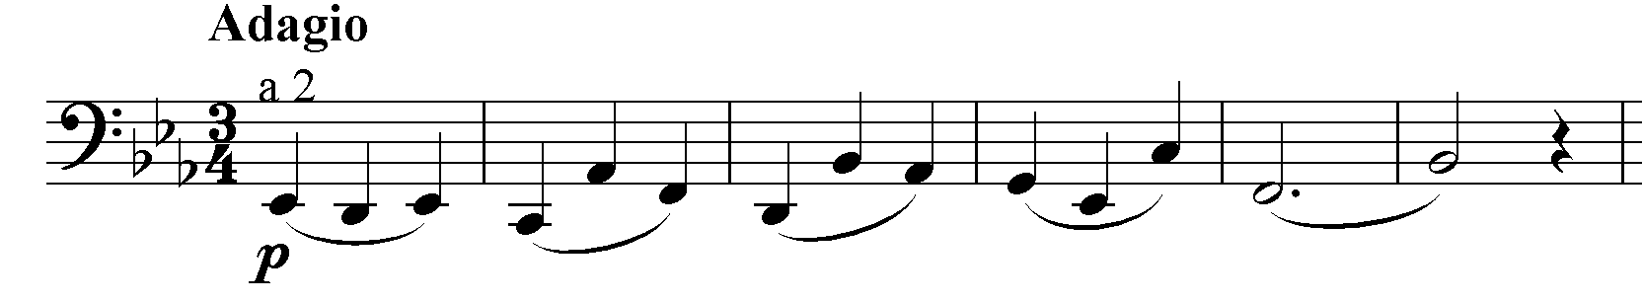

Figure 7

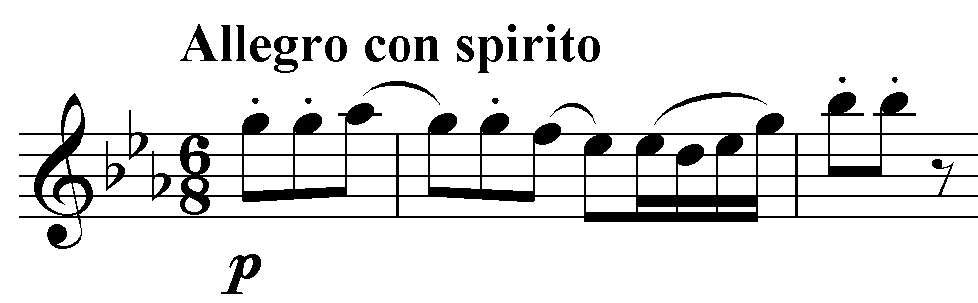

Figure 8

The second movement is a set of double variation, in alternatingly C minor and C major.[42] Clarinet is muted in this movement and the rest follows accordingly. The two melodies of this movement are based on two folk-songs from *Oedenburg* district, which are *‘Na Travniku’* and *‘Jur Postaje’* respectively.[43] Figure 9 and figure 10 show the melodies from first violins in this movement.

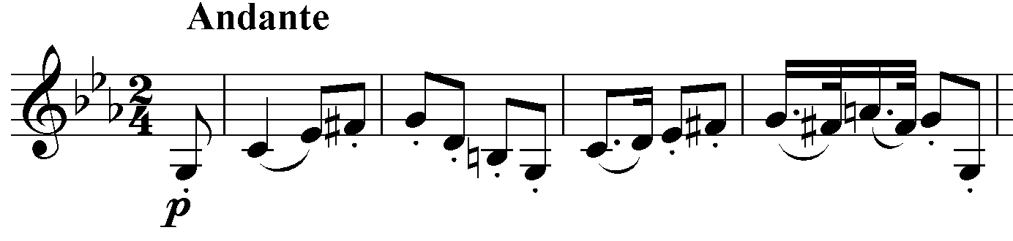

Figure 9

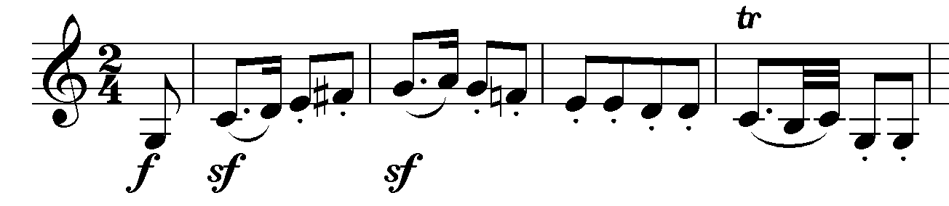

Figure 10

The third movement returns to the tonic key, which is E flat major. Menuetto starts with a yodel melody in flutes and first violin. The joke is more obvious when it modulates to C flat major and the yodel is turned into ‘art music’.[44] Trio has given a chance for clarinets to present their tone, but it was doubled over with violins very carefully.[45]

The finale of this symphony is the longest finale of the all London Symphonies, one of the reasons is that it is in sonata rondo form.[46] Folk-like melody is also used in this movement as a main theme; it is from an old Croatian song named ‘Divojcica potok gazi’ as shown in figure 11.[47] This movement begins with a horn call and then becomes the accompaniment for the Croatian folk-song theme. This theme is carried throughout the whole movement.

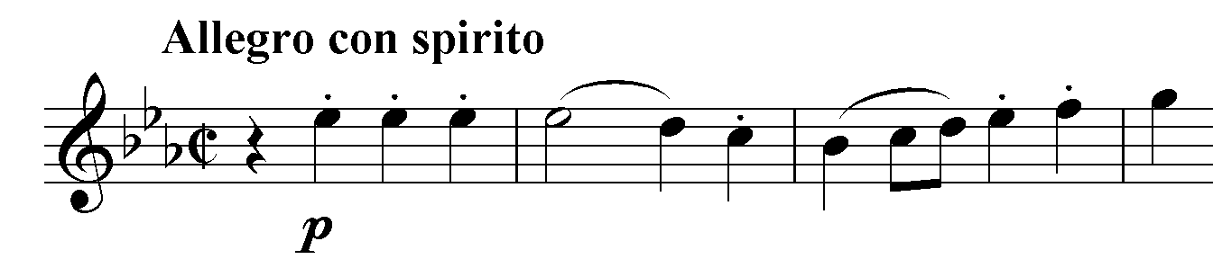

Figure 11

As it can be seen from Symphony no.103, the orchestration has a great development in his late symphonies. Especially, this symphony that features the timpani and that is why it has earned the name of drumroll. Furthermore, folk-song has been a notable feature in his late period. Symphony no.103 shows that folk-like melodies are used intentionally, and these melodies are from Haydn’s childhood memories. Besides that, other materials such as the horn call is also a feature in his late symphonies.

In conclusion, Haydn’s symphonies from each period have their own distinguishing features. His early symphonies were influenced by composing techniques from Baroque period. Moving on to his middle symphonies, he started to use *Sturm und Drang* style to express more dramatic music. While the final stage of Haydn’s the symphonies was mature and more musical styles were explored, such as folk-songs being used in Symphony no103. By the end of Haydn’s career, the symphony has become a dramatic performance that could attract audiences all rounds. Also, Haydn influenced many of his contemporaries and the later composers, such as Beethoven and Mozart. For example, the idea of syncopation and dynamic changing in Symphony no.52 influenced Beethoven’s Symphony no.5. Besides that, Haydn developed woodwind instruments as well, especially the use of clarinet. Due to the influence of Haydn, Mozart developed the use of clarinet, and he even composed a concerto work for clarinet. Finally, the symphony had become an important orchestral genre and Haydn established the symphony as the one of the important genres in western classical music. This essay has then showed how Haydn’s symphonies developed from the early to late period, and the outstanding features in the respective period.

**Bibliography**

**Online Articles**

1. Churgin, Bathi: ‘Sammartini, Giovanni Battista’, Grove Music Online (Oxford University Press, 2016), accessed 18 October 2016, <http://www.oxfordmusiconline.com/subscriber/article/grove/music/24463>
2. Webster, James and Feder, Georg: ‘Haydn, Joseph’, Grove Music Online (Oxford University Press, 2001), accessed 18 October 2016, <http://www.oxfordmusiconline.com/subscriber/article/grove/music/44593>
3. Webster, James and Feder, Georg: ‘Haydn, Joseph: Orchestral music’, *Grove Music Online* (Oxford University Press, 2001), accessed 20 October 2016, <http://www.oxfordmusiconline.com/subscriber/article/grove/music/44593pg10>

**Books**

1. Burkholder, Peter J, Grout, Donald Jay, and Palisca, Claude V: *A History of Western Music*, 9th edition. (New York and London: W.W. Norton and Co., 2014)
2. Clark, Caryl: *The Cambridge Companion to Haydn* (Cambridge: Cambridge University Pass, 2005)
3. Vickers, David: *Haydn: His Life and Music* (China: Naxos Books, 2008)
4. Landon, H. C. Robbins: *Haydn: Chronicle and Works: The Early Years* (Bloomington: Indiana University Press, 1976)
5. Landon, H. C. Robbins: *Haydn: Chronicle and Works: Haydn at Eszterhaza* (Bloomington: Indiana University Press, 1976)
6. Schroeder, David: *Haydn and the Enlightenment: The Late Symphonies and their Audience* (Oxford: Clarendon Press, 1990)
7. Landon, H. C. Robbins: *Haydn: Chronicle and Works: Haydn in England* (Bloomington: Indiana University Press, 1976)

**Scores**

1. Haydn, Joseph: Symphony no.8 in G major, “Le Soir” (Vienna: Ludwig Doblinger, 1965)
2. Haydn, Joseph: Symphony no.52 in C minor, (Salzburg: Haydn-Mozart Presse, 1960)
3. Haydn, Joseph: Symphony no.103 in E flat major, “Drumroll” (Salzburg: Haydn-Mozart Presse, 1967)

1. Churgin, Bathi: ‘Sammartini, Giovanni Battista’, Grove Music Online (Oxford University Press, 2016), accessed 18 October 2016, <http://www.oxfordmusiconline.com/subscriber/article/grove/music/24463>.
2. Burkholder, Peter J, Grout, Donald Jay, and Palisca, Claude V: *A History of Western Music*, 9th edition. (New York and London: W.W. Norton and Co., 2014), 513.
3. Webster, James and Feder, Georg: ‘Haydn, Joseph’, Grove Music Online (Oxford University Press, 2001), accessed 18 October 2016, <http://www.oxfordmusiconline.com/subscriber/article/grove/music/44593>.
4. Burkholder, Peter J, Grout, Donald Jay, and Palisca, Claude V: *A History of Western Music*. 528.
5. Ibid.
6. Ibid, 529.
7. Webster, James and Feder, Georg: ‘Haydn, Joseph: Orchestral music’, *Grove Music Online* (Oxford University Press, 2001), accessed 20 October 2016, <http://www.oxfordmusiconline.com/subscriber/article/grove/music/44593pg10>.
8. Ibid.
9. Clark, Caryl: *The Cambridge Companion to Haydn* (Cambridge: Cambridge University Pass, 2005), 102.
10. Vickers, David: *Haydn: His Life and Music* (China: Naxos Books, 2008), 25.
11. Landon, H. C. Robbins: *Haydn: Chronicle and Works: The Early Years* (Bloomington: Indiana University Press, 1976), 558.
12. Worth, Neil Butter: *Haydn: His Life and Times* (Kent: Midas Books, 1977), 32.
13. Landon: *Haydn: Chronicle and Works: The Early Years*, 558,
14. Landon: *Haydn: Chronicle and Work: The Early Years*, 558.
15. Vickers, David: *Haydn: His Life and Music*, 182.
16. Landon: *Haydn: Chronicle and Work: The Early Years*, 559.
17. Ibid.
18. Webster, James and Feder, Georg: ‘Haydn, Joseph: Orchestral music’.
19. Ibid.
20. Burkholder, Peter J, Grout, Donald Jay, and Palisca, Claude V: *A History of Western Music*. 532.
21. Ibid.
22. Webster, James and Feder, Georg: ‘Haydn, Joseph: Orchestral music’.
23. Landon, H. C. Robbins: *Haydn: Chronicle and Works: Haydn at Eszterhaza* (Bloomington: Indiana University Press, 1976), 299.
24. Schroeder, David: *Haydn and the Enlightenment: The Late Symphonies and their Audience* (Oxford: Clarendon Press, 1990), 77.
25. Landon: *Haydn: Chronicle and Work: Haydn at Eszterhaza*, 299.
26. Landon: *Haydn: Chronicle and Work: Haydn at Eszterhaza*, 299.
27. Ibid.
28. Ibid.
29. Landon: *Haydn: Chronicle and Work: Haydn at Eszterhaza*, 299.
30. Ibid.
31. Burkholder, Peter J, Grout, Donald Jay, and Palisca, Claude V: *A History of Western Music*. 533.
32. Ibid.
33. Ibid.
34. Ibid.
35. Ibid.
36. Ibid.
37. Webster, James and Feder, Georg: ‘Haydn, Joseph: Orchestral music’
38. Landon, H. C. Robbins: *Haydn: Chronicle and Works: Haydn in England (*Bloomington: Indiana University Press, 1976), 595.
39. Ibid.
40. Ibid, 597.
41. Ibid.
42. Ibid.
43. Ibid, 598.
44. Landon: *Haydn: Chronicle and Work: Haydn in England*, 601.
45. Ibid.
46. Ibid, 602.
47. Ibid.